Excel Project: Market Entry Model

Author: Emily Kokol-Rivera | Date: October 2025 | GitHub: [Insert GitHub Link]

# Project Overview

This Excel model projects unit sales, revenue, costs, and profit across multiple years to evaluate new market entry strategies. It includes a dynamic assumptions block, base/best/worst-case scenario selector, profit and revenue charts, and sensitivity analysis to test how changes in market share or pricing impact profitability. Designed for business analysts and decision-makers, the model demonstrates financial modeling, scenario planning, and Excel automation techniques.

# Tools & Skills Demonstrated

* Excel Tables and Structured References
* Scenario Analysis (Base, Best, Worst Cases)
* XLOOKUP and Named Ranges
* Data Tables for Sensitivity Analysis
* Financial Modeling (Revenue, Cost, Profit Projections)
* Chart Design (Column and Line Charts)
* Dynamic Assumption Linking with Dropdown Selector
* Business Case Modeling and Decision Analysis

# Dashboard Snapshot

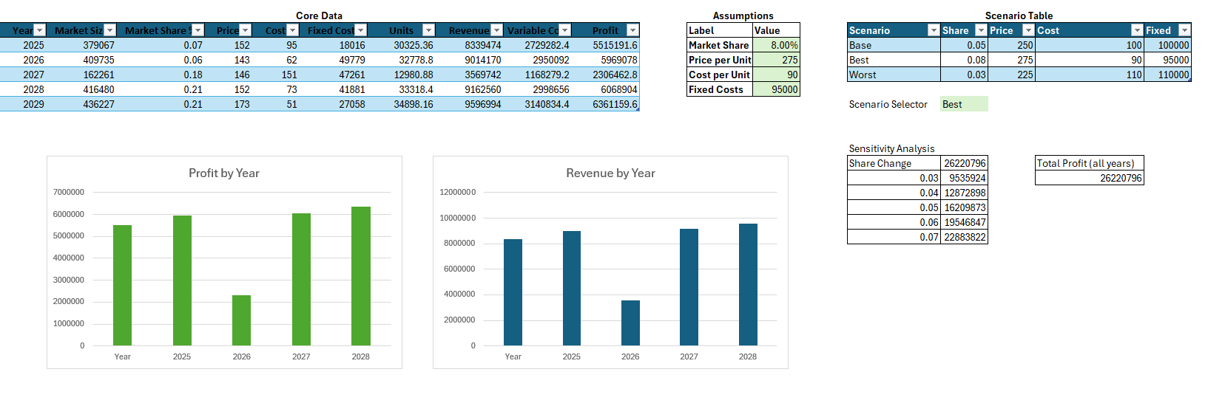

# Key Insights

* Profitability is most sensitive to changes in market share — even small percentage increases yield significant gains.
* The “Best Case” scenario demonstrates how optimizing both price and unit cost can expand margins while maintaining volume.
* Scenario trends show consistent revenue growth year over year, with the highest gains realized when fixed costs are minimized.

# Learning Reflection

Building this model strengthened my skills in structured financial modeling, scenario planning, and sensitivity analysis using Excel’s XLOOKUP and Data Table tools.